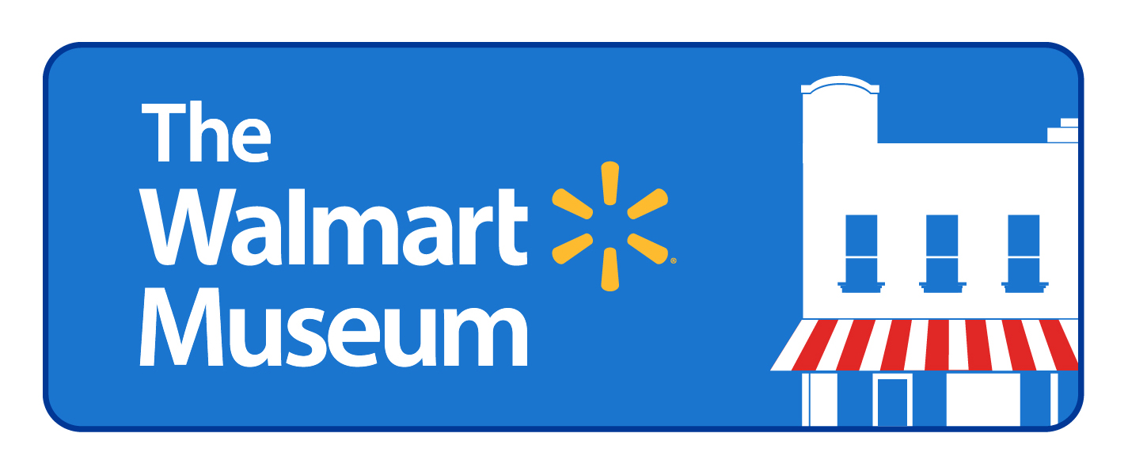

For Immediate Release Media Relations Contact
Walmart Media Relations
800-331-0085

Walmart Celebrates Creativity, Gratitude with NWA Art Event
More than 25,000 works of art from area students to be displayed at Jones Center

BENTONVILLE, Ark., Jan. 3, 2014 –Parents and children of all ages are invited to participate in a celebration of creativity hosted by Walmart and The Walmart Museum at the Jones Center for Families, Saturday, Jan. 11 from 9 a.m. to 2 p.m. More than 25,000 works of art created by area students will be on display at the Jones Center from Jan. 11 through summer 2014.

The installation is a product of Everyartist Live! During this nationwide art event, children in Benton and Washington counties and across the U.S. created original pieces of artwork with the theme of gratitude in mind. Their creative works are now on display at The Jones Center for Families, Crystal Bridges Museum of American Art, The Walton Arts Center and The Walmart Museum.

Everyartist Live! is part of a partnership between The Walmart Museum, Walmart and Everyartist.me, an organization that seeks to foster the creative development of children around the country.

“It’s important for Walmart to be involved in programs like this that engage our associates and their children, and also embody the ‘live better’ side of our mission,” said Alan Dranow, senior director of the Walmart Heritage Group. “The celebration provides an opportunity for parents and children to see their own art on display as well as enjoy a special day with other student artists from across Northwest Arkansas.”

Art will be grouped by school district at the Jones Center, allowing children and parents to browse and view thousands of works while enjoying complimentary refreshments and musical entertainment. In addition, the Jones Center is offering free access to the pool, gym, and ice rink during public sessions Jan. 11.

A short program about Everyartist Live! will begin at 11 a.m. and will feature speakers including Alan Dranow, senior director of the Walmart Heritage Group; Brendan O’Connell, co-founder of Everyartist.me and the artist behind “The Walmart Series” collection; and Ed Clifford, CEO of the Jones Center for Families.

About The Walmart Museum
The Walmart Museum offers visitors a chance to see “the birthplace of Walmart “ and learn all about Walmart’s history and culture. Located at the site of the original Walton’s 5&10 on the Bentonville town square, the Museum’s multi-room gallery showcases Sam Walton's life and leadership in making Walmart into a company that helps customers save money and live better. Visitors to The Walmart Museum can take a step back in time and experience a piece of Sam Walton’s history through a working five-and-dime store, complete with vintage toys, games and candies, and the Spark Café, an old-fashioned soda fountain featuring ice cream, sweet treats and beverages. Learn more about events at The Walmart Museum and local programming by visiting our Facebook Page.

About Everyartist.me
Everyartist, at its core, seeks to unleash the creativity innate in every child. The organization is carrying out this mission by creating a national collaborative art event designed to foster the creative development in children around the country. Numerous research studies and experts in the field believe that supporting the creativity of children and giving them an outlet to express themselves is just as important as the work that is done in Reading/Writing, Science and Math. Budgets for arts programs across the country are experiencing deep cuts due to education policies, narrowing school curricula, and an undervaluing of the arts experience. And yet, a growing body of research indicates that the arts are essential for academic achievement, social engagement, and innovative thinking. Find out more about how Everyartist came to be and how to get involved here: http://Everyartist.me

###

